Cording Standards

Connection Connection String create a inside the .Config file
- Should Deploy inside the Server
- Global Connection

Form
- frm<Form name >

- Use Meaning full name
- First Letter capital
- Do not use other special characters (ex: underscore) in between two words

- Ex:-frmClientMaster

- Do not use- frmClient_Master

- All forms must need Exit button
- All buttons must need keyboard access methods.

- Form type - Fixed dialog

- Set following properties
- Maximize = false
- Help window = false
- Minimized=False

- Font name – Default font –M/S scan serif 8.25
- Font size - Default font size -8.25

- Normal button size – 77, 25
- Button name – Default font (M/S scan serif 8.25 ) –font bold

Frame
- Font –default (M/S scan serif 8.25) –Bold
- Color- Dark blue

Functions

Comment Line - must include following comment lines each & every functions.
/***************************************************************
/* Function Name:
/* Author:
/* Date:
/* Comment < small briefing about function >
/***************************************************************
If modify the function should have Modified date and modified developer name.

Error handling

Need to handle run time errors through the function
Error handling each and every function

[Try //// Catch]

Function Naming

If return data

Function name - <Return data type>_<Function name>

Ex:-DR_Getbydate

Type-Data reader

Else

Use Meaning full name
First Letter capital
Do not use other special characters (Ex: - underscore) in between two words

Ex: PremiumComputation
Do not use- Premium_Computation

Global function naming

gbf<function name>

Class Naming

Cls<class name>

Variable Define

Integer – int< Integer name>

String - str< String name>

Long – lng< Long name>

Date - dtm<Date name>

Currency - cur< Currency name>

Double - dbl-< Double name>

Boolean – boo< Boolean name>

Global variables

Ex: - int <gbl><Variable name>

Name First Letter is capital.

Ex: StrEmployeeNo

Common Control Naming

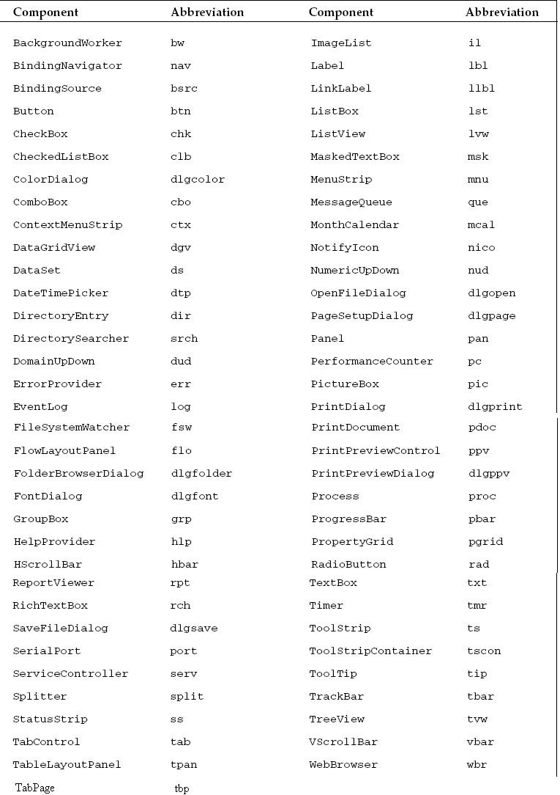
Button Name | Description
btnSave | Save Information
btnDelete | Delete Information
btnView | View Information
btnExit | Exit Menu
btnProcess | Processing

Constant Names

For constants, use uppercase words separated by underscores, as in the following example:

Eg.Const MAX_USERS As Integer = 10

Routine Variable Names

Declare variables within a as shown in the following example:
Dim numItems As Integer
Dim totalCost As Decimal
Dim salesTax As Decimal
Parameters to a routine are declared within the context of the routine, so treat them as routine-level variables. For example, in the following code, the filePath and fileTitle parameters follow this naming convention:
Public Sub LoadData(ByVal filePath As String, ByVal fileTitle As String)
...
End Sub

Other Names

For names that are not constants and that are not declared within routines, use Pascal case (with the first letter in each word capitalized). For example, a method that generates a new invoice might be called GenerateNewInvoice.

When defining an enumerated type, add “Types” to the end of the name. That lets me use the same name (minus the “s” in “Types”) as the name of a property having that type. For example, the following code uses the ShapeTypes enumeration that defines some shape types. The ShapeType property has type ShapeTypes.

Public Enum ShapeTypes
Line
Ellipse
Rectangle
Polygon
End Enum
Private m_ShapeType As ShapeTypes
Public Property ShapeType() As ShapeTypes
Get
Return m_ShapeType
End Get
Set(ByVal value As ShapeTypes)
m_ShapeType = value
End Set
End Property

Property Names
Make the names of properties nouns or noun phrases such as TextColor, LineWidth, Straightness.

Method Names
A subroutine makes an object do something, so its name should reflect that by indicating an action. Give subroutines names that are verbs or verb phrases. For example, some good subroutine names include
PrintInvoices, DeleteItem, and Execute.
Avoid names that could be interpreted as either nouns or verbs. For example, don’t use the name Color for a subroutine that colors a shape, because someone reading the code might read Color as a noun and assume it is a property rather than a subroutine.
Usually, you can avoid this issue by adding an extra word. In this case, you could change the subroutine’s name to ColorShape.

Event Names
For events that occur before the code takes some action, end the event’s name with the “ing” form of a verb, as in Clicking, Changing, Moving, or Canceling. For events that occur after the code takes some
action, end the event’s name with a verb in the past tense, as in Clicked, Changed, Moved, or Canceled.
Make the rest of the name explain the thing to which the verb applies—for example, SeatClicked,
CustomerChanged, DrawingObjectMoved, or JobSchedulingCanceled.
Add EventHandler to the end of event handler names, as in the following code:
Public Delegate Sub SeatClickedEventHandler(ByVal seat_clicked As Seat)

This makes sense when you are declaring a delegate. Later, when you declare a variable with the delegate’s type, the name makes it easier to understand that this is an event handler.
Dim clicked_event_handler As SeatClickedEventHandler

Block Endings
Add a comment at the end of blocks of code that are more than a few lines long to tell the reader what is ending. The previous section included comments at the end of If Then and Select Case blocks. You should also add comments at the end of subroutines, functions, classes, modules, regions, and other long blocks of code so that the reader can tell what code is ending.
The following code shows a module that contains a region holding some functions. Comments at the end of each of these give the name of the block they are ending.

Module Geometry
...
#Region “Convex Hull Code”
Private Function FindConvexHull(ByVal points() As Point) As Point()
...
End Function ‘ FindConvexHull
Private Function CullHull(ByVal points() As Point) As Point()
...
End Function ‘ CullHull
...
#End Region ‘ Convex Hull Code
...
End Module ‘ Geometry

Overloading and Optional Parameters

If you want optional parameters, use optional parameters instead of overloaded methods. Use overloaded methods if you want to use parameters that can be included or omitted as a group. Also use overloaded methods if you have a good reason for allowing different versions of a method to take different parameters (as opposed to rearranging parameters to provide versions that do different things).

Exit For, Exit Do, and Continue
Just as an Exit Sub or Exit Function statement breaks the normal rules of program control flow, the Exit For, Exit Do, and Continue statements break the normal rules for moving through a loop.
Just as you can rewrite code to avoid using Exit Sub and Exit Function, you can rewrite code to avoid using these statements, but, as is the case with Exit Sub and Exit Function, you may make the code less readable.

Stored Procedure naming

Comment Line - must include following comment lines each & every stored procedure.
/***************************************************************
/* Function Name:
/* Author:
/* Date:
/* Comment < small briefing about function >
/***************************************************************
If modify the function should have Modified date and modified developer name.

Delete

SP_Del<name>

Insert

Sp_Ins<name>

Update

Sp_Upd<name>

